**TRANSFER LEARNING:**

Transfer learning is a process in which instead of training the deep learning architecture from scratch it focuses on storing knowledge gained while solving one problem and applying it to different but related problem. Practically, Reusing or Transferring information from previously learned tasks for the learning of new tasks.

**Types of Transfer Learning Architectures:**

Transfer Learning architectures are designed on the domain specific applications. Two Domains are the problems related to Computer Vision and Natural Language Processing.

**1.Computer Vision Architectures:**

* VGG16
* VGG19
* GOOGLENET OR INCEPTION V3
* XCEPTION
* RESNET50

**2. Natural Language Processing Architectures:**

* WORD2VEC
* GLOVE
* FASTEXT

**DESCRIPTION OF ARCHITECTURES:**

**1.VGG 16 (Veterans for Good Government 16):**

As the Name suggests that VGG16means that there are total 16 layers in the deep neural network Archictecture. Out of them13 are Convolutional layers and 3 are fully connected layers.

.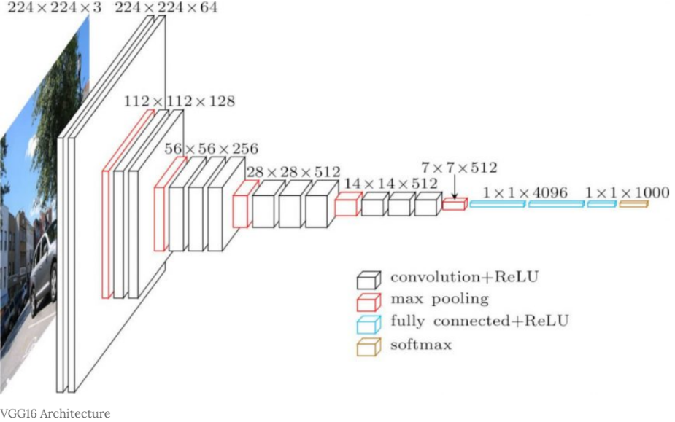

Number of Layers: 16

Type of Layers: Convolution Layers, Max pooling Layers and Fully connected Layers

Data used for Training: ImageNet Data

Required Input shape of Data: (224 X 224 X 3)

Output; 1000 classes

Loss Function: Mean Squared Error (MSE)

Drawbacks:

* Takes more time to Train the network
* As the network weights architecture are too large due to its depth and fully connected layers in architecture.

Applications of VGG16: Any Image classification tasks such as object detection and multi label class tasks.

**2. GoogleNet:** The GoogleNet Network was recently one of breakthrough in outperforming the tasks provided by CNN. The main idea to develop such a architecture was from the drawbacks from the vgg as the network was deeper and will prone to overfitting. So instead Google team tried instead of deeper networks they processed wider networks. One such block/layer is called inception layer.

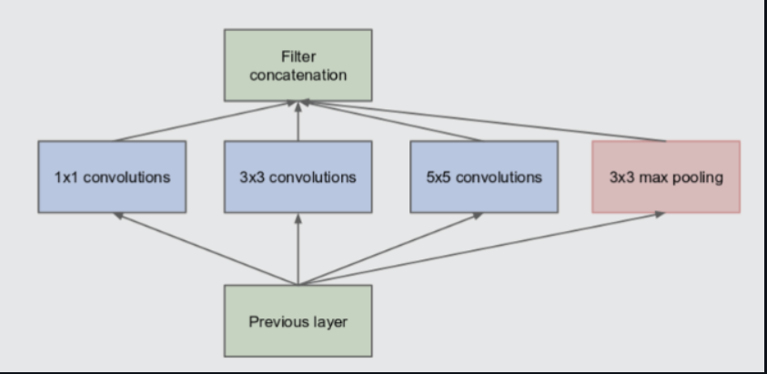

As can be seen in above diagram,the convolution opration is performed n inputs with three filter sizes. A max pooling operation is also performed with the convolutions and then it is sent to next inception module.

The GoogleNet Architecture is 22 layers deep, with 27 pooling layers included. There are 9 inception modules stacked linearly in total. The ends of the inception modules are connected to the global average pooling layer.

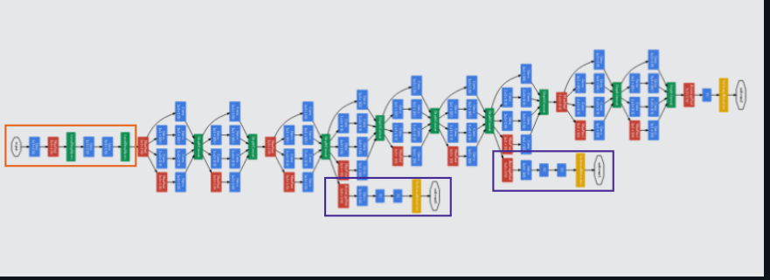

Number of Layers: 22

Type of Layers: Convolution Layers, Max pooling Layers and 9 Inception modules

Data used for Training: ImageNet Data

Required Input shape of Data: (224 X 224 X 3)

Output; 1000 classes

Loss Function: weighted sum of auxiliary loss and real loss.

Drawbacks of Googlenet:

* More computational power, but this was overcomed by future versions of Inception.

**3.ResNet:**

As deep neural networks are both time-consuming to train and prone to overfitting, a team at Microsoft introduced a residual learning framework to improve the training of networks that are substantially deeper than those used previously. And so the Name Residual Network or ResNet was came.

As number of layer increases in depth there arises another problem which is called vanishing gradient . Vanishing gradient is a problem when error is back propagated then some of the weights gets either vanished or exploded. In order to overcome this problem Microsoft proposed an Architecture which is similar to VGG19 but allowing a block called skip connection in which it skips some of the few layers from input and directly connects to the output .This is one of the best advantage of this Network.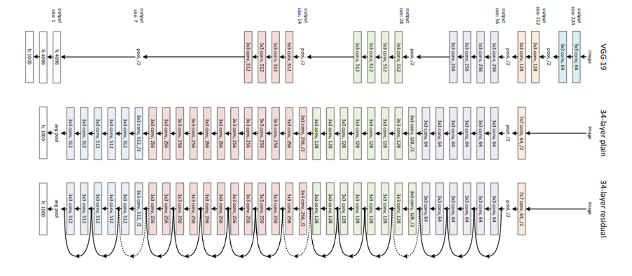

Number of Layers: 34

Type of Layers: Convolution Layers, Max pooling Layers and Skip connections

Data used for Training: ImageNet Data

Required Input shape of Data: (299 X 299 X 3)

Output; 1000 classes

Loss Function: log loss